**Steps to take backup & Restoration of Azure VM**

To take backup of Azure VM, Azure use **recovery services vault**. Recovery services vault is used for VM which was created Resource Manager.

1. Go to the VM and search Backup option to start backup configuration procedure

A screenshot of a computer

Description generated with very high confidence

2.

If recovery services Vault is not already present. We will create a new one and configure the backup policy and retention policy of backup in recovery services vault.

A screenshot of a computer

Description generated with very high confidence

3.

After going to Azure Services recovery vault, we click on the Backup items, and then select the Azure Virtual machine to take backup

A screenshot of a computer

Description generated with very high confidence

4. Select the respective Virtual Machine for which we have to take backup

A screenshot of a computer

Description generated with very high confidence

5.

After selecting the VM, we select the backup policy either to be daily or weekly backup.

A screenshot of a cell phone

Description generated with very high confidence

6.

Select the retention policy for back up of VM. i.e for how long you want to keep the backup of VM

A screenshot of a social media post

Description generated with very high confidence

7.

After clicking on “Backup Now” button wait for one hour or more(Approx.) to complete backup process.

You can see the progress of Backup of VM using following screen

A screenshot of a cell phone

Description generated with very high confidence

8.

After completion of Backup Job. Open main Azure Recovery services vault and select **Backup item** and then **Azure Virtual Machine**

A screenshot of a cell phone

Description generated with very high confidence

9.

After the verification of Backup Process that if it was successful or not, select the backup of VM to be restored

A screenshot of a cell phone

Description generated with very high confidence

10.

Select the Restore VM button to begin Restoration process of VM

A screenshot of a social media post

Description generated with very high confidence

11.

If the backup is configured weekly or daily, you have to select the latest backup to be restored

A screenshot of a cell phone

Description generated with high confidence

12.

Select the Storage account, which was used while creating the VM (Where the actual VHD is present )

Normally, it is 127 GB VHD file

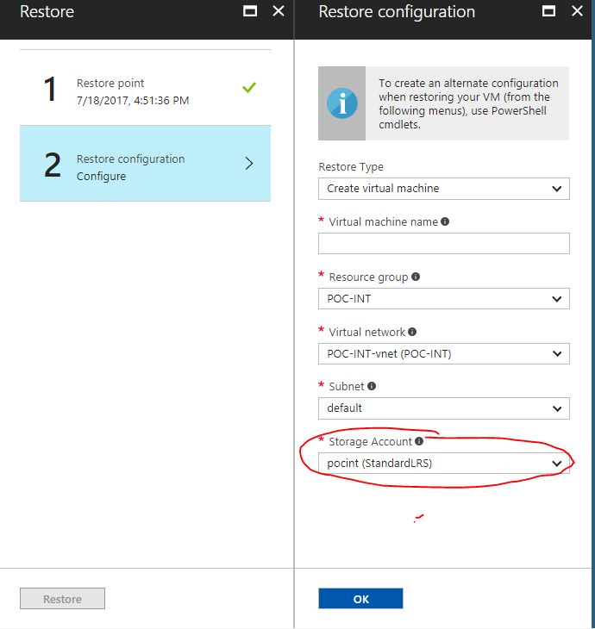

The restoration Process take one to two hours for its completion. You can see the Progress of Azure VM restoration using the way as same of Backup

You get a notification in notification bar when the restoration job is completed.

**Note**: if you do not get the RDP (Connect button) file of restored VM then you should change the Network Security Group NSG, inbound rules for newly restored VM.

For editing NSG settings, select network interface option and then select the NSG to be changed